Meriweather Mowing
Meriweather Management System Proposal


Mariweather Mowing
Meriweather Management System
Revision 1.0

NOTICE OF PROPRIETARY AND CONFIDENTIAL INFORMATION:

This document contains proprietary and confidential information governed by the following terms and conditions.
- This document is and shall remain the property of ______. It may not be copied without prior approval of ______. Any copies made must include all proprietary notices included on the original(s). This document shall be returned to ______promptly at its request together with all copies made thereof.
- Confidential information shall be used by the parties solely for purposes of providing evaluation, and the results of such evaluation shall also be considered confidential information. Evaluators shall not disclose the confidential information or any part thereof to any person, firm, or corporation and shall further restrict dissemination of the confidential information.
- Notwithstanding the foregoing, evaluators shall not be required to protect or hold in confidence any confidential information which (a) is or becomes part of the public domain, (b) is known to and is reduced to writing by the evaluator prior to the disclosure by ______, or (c) is subsequently rightly received by the evaluator from a third party.
- In the event of any unauthorized disclosure of confidential information by the evaluator or any representative of its party, both parties shall cooperate in enforcing the terms of any agreement binding such representative to the non-disclosure or proprietary, confidential or trade secret information.
- Information presented in this document is speculative. ______makes no warranty as to its accuracy, and no commitment regarding the content, development, or scheduled release of products or services described herein.

NOTICE OF TRADEMARK:

______ Meriweather Management System are trademarks of ______Corporation.
Microsoft and Microsoft Windows are registered trademarks of Microsoft Corporation.

© Copyright, 2009 ______Corporation
All Rights Reserved
Charlottesville, VA 22901
Phone 800.555.5555 • Fax 800.555.5555
www.meriweather.com

Table of Contents

Introduction 1
About 1
Software Feature Set 1
Architecture 5
Please leave this page blank. 6

Introduction
Management System program proposal for Meriweather Mowing Company. The purpose of this document is to describe the general functionality that are necessary to meet business objectives of the Meriweather management system software. This document will approximate all of the Meriweather management system version 1.0 functional and non-functional requirements for the software product.

About

This software program object is to improve processes and expand on the technology for Meriweather Mowing. The following are functionality for the initial proposal for the new management system.

Software Feature Set
This document specifies functionality specific to the Meriweather Manangement System. Those features specified in this document that are not a part of the current feature set but maybe implemented if time permits are specifically noted in italicized for format.

**Note: Future or deferred features are noted in italicized format.
- Setup
  - Company Information
  - QuickBook Setup (writes to QB db automatically)
  - Preferences
  - Printer Setup
  - Backup setup
  - Database setup – multiple database support
  - Email Settings
  - Fax setup

- Security
  - General Password protect
  - User Login account/passwords
  - Specific User Privileges

- Employees
- Employee Listing (name, address, etc)
- Add, Edit, Delete
- Search / Sort

- Contractors
  - Contractor Listing (name, address, etc)
  - Add, Edit, Delete
  - Search / Sort

- Customers
  - Customer Listing (name, address, etc)
  - Add, Edit, Delete
  - Search / Sort

- Customers Properties
- Property listing (description, address, etc.)
- Add, Edit, Delete
- Search /Sorts
- Work history
- Notes
- View Map/Directions

- Services (mow, 4step, cleaning, prices)
  - Services Listing Add, Edit, Delete
  - Search / Sort

- Materials
  - Listing- Add, Edit, Delete
  - Search / Sort

- Calendar
  - Overall Calendar
  - Add/Edit/Delete Entry
  - Allow for scheduling, crew, contractors, etc.
  - Generate Listing / Instruction Sheet
  - Generate Revenue Sheet
  - Generate Contractor Listing/Instruction Sheet
  - Generate Contractor pay sheet
  - Generate Other jobs, Listings
  - Generate Map directions

- Invoice/Billing
  - Add/Edit/Delete/Generate Invoices
  - Quickbook Export
  - Payment – add, edit, delete
  - Filter for Net 30, 60, 90, Paid, etc

- Job/Employee Analysis
  - Add/edit/delete entries
  - Generate analysis

- Reports -
  - Generate Invoices
  - Generate Statement
  - Listing of Customers, Contractors, Crew, Properties, Etc.?
  - Other reports?

- Utilities
  - Backup/Restore Data
  - Import/Export

- Tools
- Generate Letters
- Generate Estimates
- Generate newsletter

- Transaction Log
  - Current transaction s
  - Transactions/changes by employee
  - Modifications/edits
  - Cancellations

- Map Function (Map live or Google maps)
  - Map Direction Functionality
  - Route support
  - Queries, analysis, dispatch tracking
  - Push pin support for new/current/completed orders
  - Drivers en-route, GPS capable?
  - Simple messaging to crew or broadcast.

- Web Transaction Support
  - Orders/Scheduling
  - Payment, Invoicing

- Mobile Device Support
  - Utilize windows mobile
  - Receive request, directions
  - General messaging
  - Adhoc jobs

Architecture
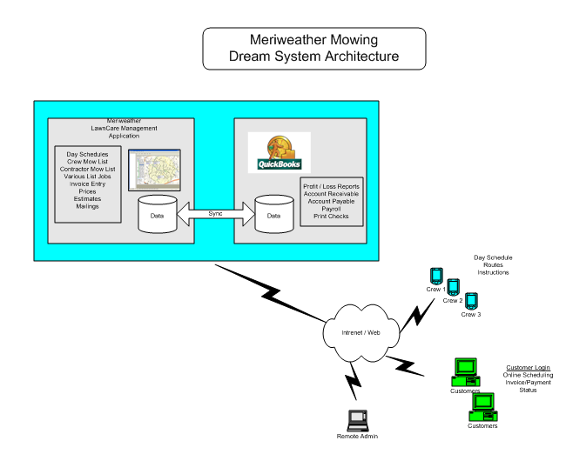
Please leave this page blank.

